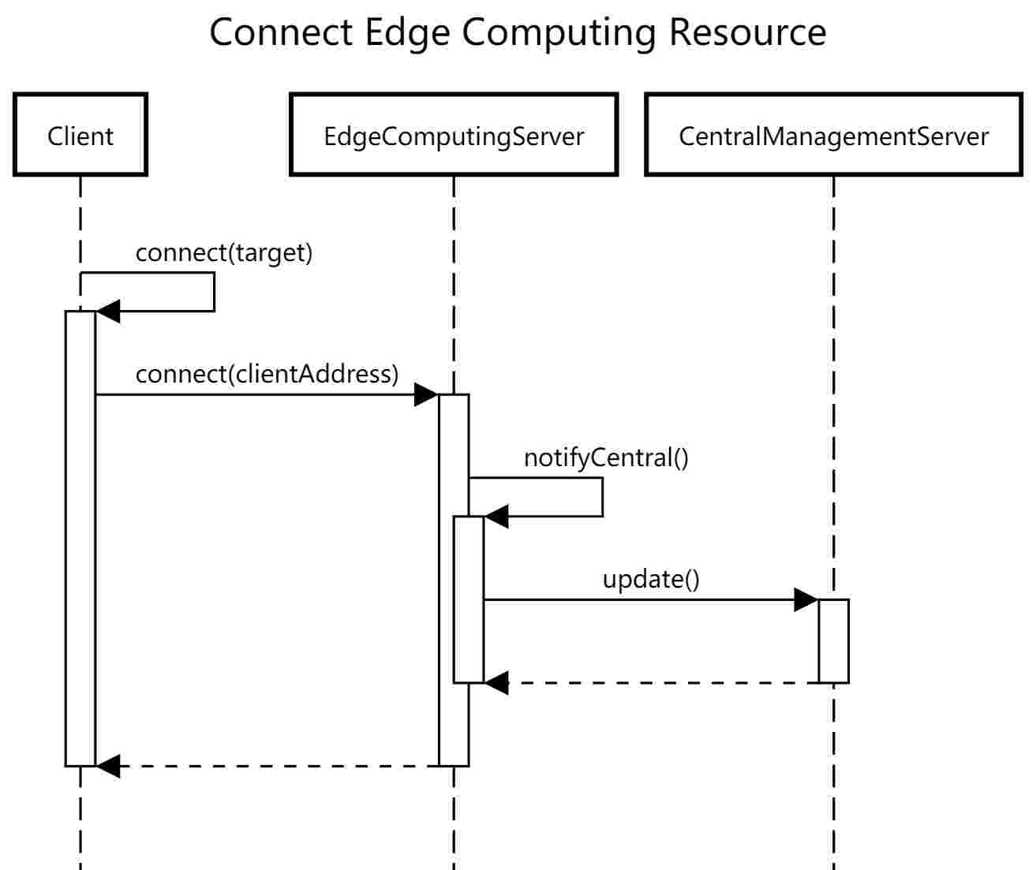

Client class call self-contained method connect to connect with Edge computing server, because we used decorate model on the implementation of client connect method , inside client connect method, EdgeComputingServer connect method will be called , and connect succeed. Then, EdgeComputingServer will notify CentralManagementServer about the rest resource of itself by calling notifyCentral method, inside notifyCentral method ,CentralManagementServer update method will be called to update the availability list stored in CentralManagementServer.

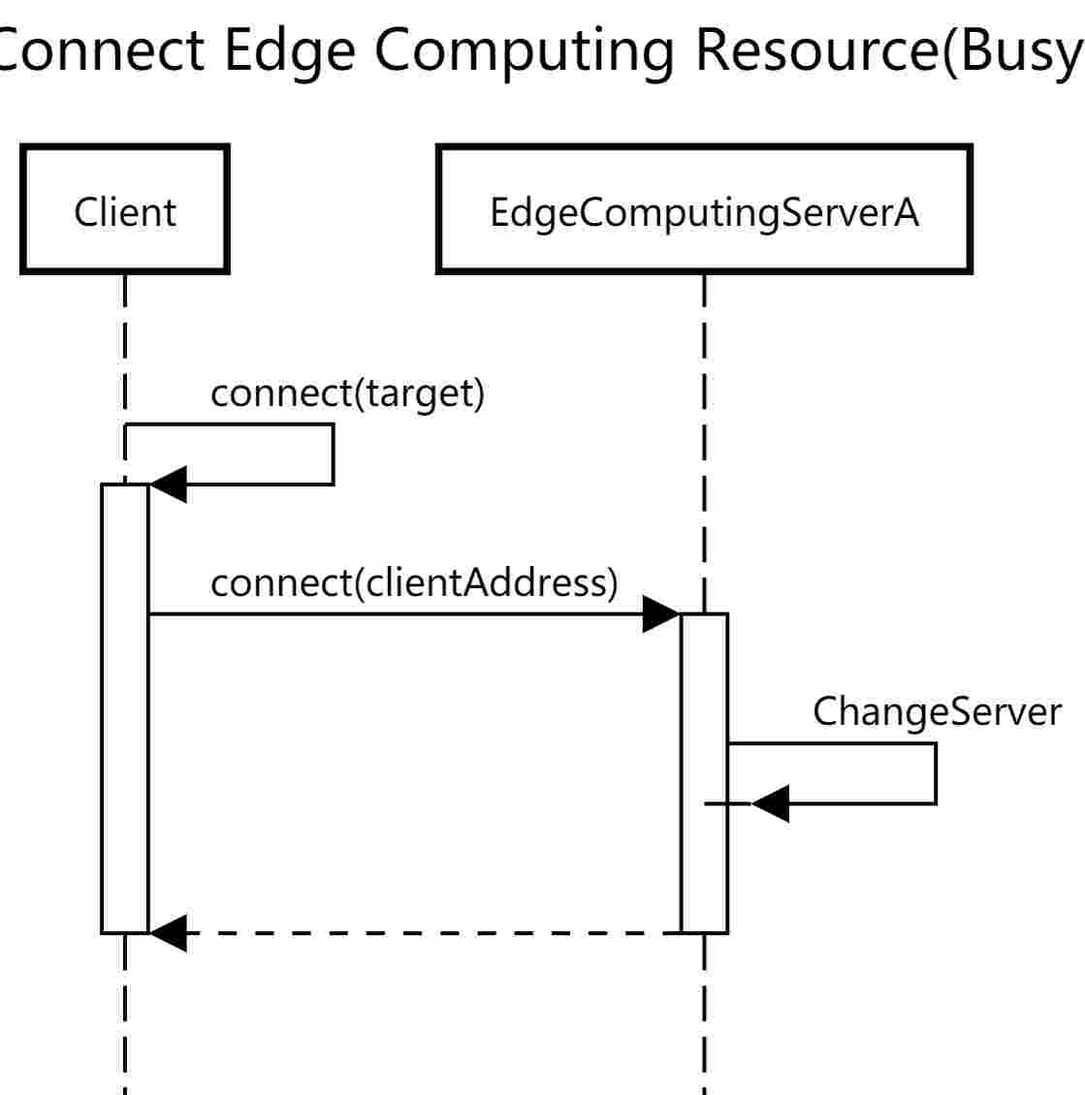

This is the case when EdgeComputingServer is overload, it need to perform Change Server use case to get client connect with other EdgeComputingServer. ChangeServer in the diagram represent ChangeServer use case

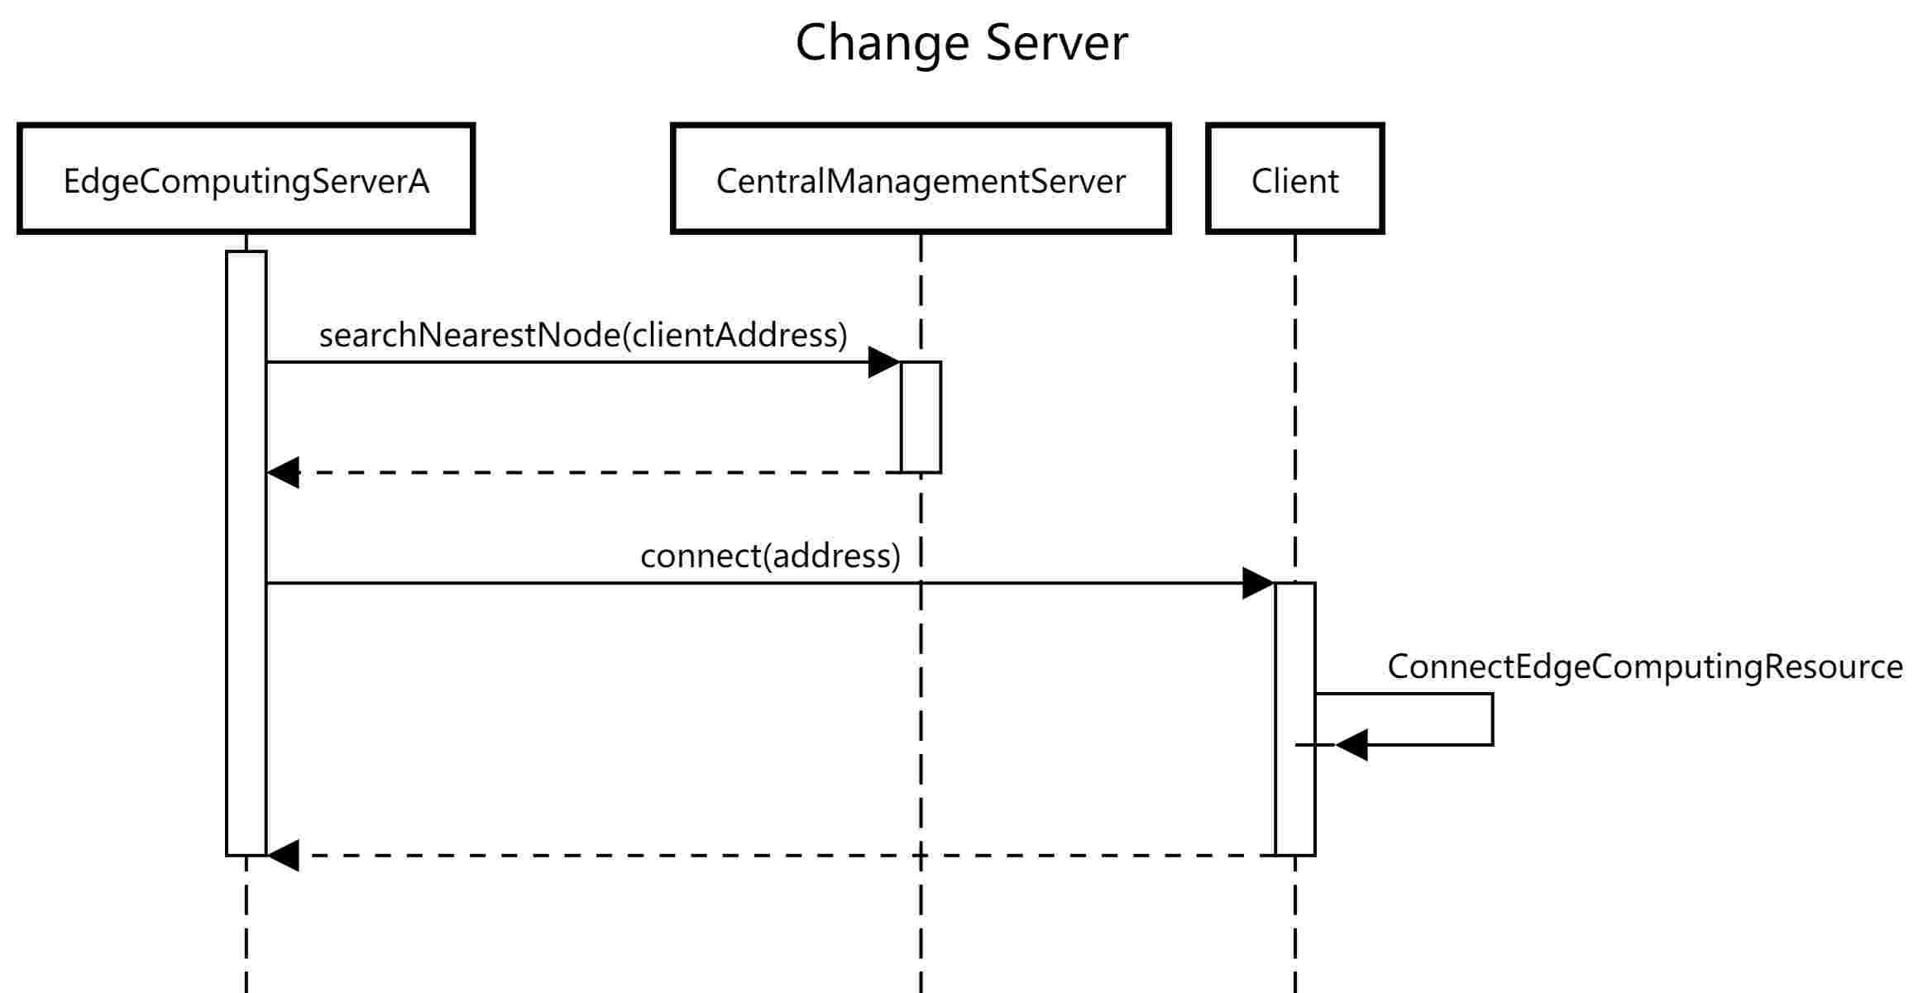

EdgeComputingServer using the CentralManagementServer method searchNearestNode to search the nearest node for a certain address. Then, call the client connect method to get the client connect with the nearest node, this involves the Connect Edge Computing Resource use case.